Expt. no: 2 Date:

Introduction to In-House Acidic Etching using a Copper-Clad Board

Objective:
- To test the circuit on a breadboard
- To practice the etching procedure
- To practice soldering and desoldering on copper-clad board
- To fabricate the PCB on a copper-clad board
- To verify the working of the PCB using a multimeter and oscilloscope
Precautions:
- This lab involves hot soldering irons and components. USE EXTREME CAUTION!!!
- The solder used in the laboratory may contain lead. DO NOT breathe fumes generated while soldering. Preferably wear masks.
- Be aware of the location of your soldering iron while it is hot and ensure you place the hot iron in an appropriate holder to prevent heat or fire damage.
- Switch off and unplug soldering tools when not in use.
- Allow the soldering tool to cool before storing.
- This lab involves the use of Ferric Chloride for etching. It is corrosive to skin, eyes, and respiratory tracts. Always wear appropriate personal protective equipment like gloves, face masks, and safety goggles. USE EXTREME CAUTION!!!
- Ferric chloride can stain clothing and surfaces. Avoid contact with skin and work in a well-ventilated area.
- Spent ferric chloride solution should be neutralized and disposed of according to local regulations. Dilute the etching solution with water as much as possible before disposing in a carefully chosen area that does not pose any danger to the environment. Do NOT flush the solution in the sink/ drain.
- While an effective etching agent, ferric chloride demands careful handling:
- Corrosive Nature: (PPE), including gloves, safety goggles, and a respirator.
- Wash your hands thoroughly with soap after performing the etching and soldering procedure.
Equipment:

Instruments: Oscilloscope, Digital Multimeter, Fume Extractor
Components:
Sr. No. | Items | Quantity
1 | Step-down transformer | (enter quantity)
2 | Pin Headers | (enter quantity)
3 | Diodes 1N4007 | (enter quantity)
4 | Resistors (2.2K) | (enter quantity)

Other material:
Sr. No. | Items | Sr. No. | Items
1 | Copper-clad Board (3” X 3”) | 8 | Ferric Chloride powder
2 | PCB Cutter | 9 | Flux
3 | Scrubber, IPA solution | 10 | Soldering iron
4 | Permanent marker to draw track pattern | 11 | Helping hand clamps/ Tack
5 | Tissue paper/ cotton | 12 | Face mask, gloves
6 | Soldering wire | 13 | Brass wire sponge for tip cleaning
7 | Flat-bottom container of size to fit the PCB, half-filled with water | 14 | Wet Sponge for tip cleaning

Theory:

PCB etching

Ferric chloride etching is a type of chemical etching where a controlled chemical reaction removes material from a metal surface. The process hinges on the oxidation-reduction (redox) reaction between ferric chloride and the metal being etched.

When a metal, such as copper, comes into contact with the ferric chloride solution, the metal atoms lose electrons (oxidation) and dissolve into the solution as metal ions. Simultaneously, ferric ions (Fe3+) in the solution gain electrons (reduction) provided by the oxidizing metal, converting into ferrous ions (Fe2+). This redox reaction results in the etched metal being carried away as a soluble metal salt (e.g., copper chloride) and the ferric chloride being reduced to ferrous chloride.

Factors Influencing Etching Rate: Fine-Tuning for Precision

The rate at which ferric chloride etches metal is influenced by several key factors:
- Concentration: Higher ferric chloride concentrations generally lead to faster etching rates. However, extremely high concentrations can result in rougher etch profiles.
- Temperature: Etching is a temperature-dependent process. Warmer solutions etch faster, but excessive heat can degrade the etchant and pose safety risks.
- Agitation: Stirring or agitating the etching bath ensures a fresh supply of ferric chloride reaches the metal surface, promoting consistent etching.
- Metal Type: Different metals exhibit varying reactivity with ferric chloride. For instance, copper etches faster than stainless steel.

Procedure to perform the experiment:
- Assemble the circuit components on the breadboard and test the working.
- Observe the waveform, note the measured values of resistance and the output voltage, and calculate the ripple factor. Plot the rectified output graph.
- Cut the PCB to an appropriate size.
- Clean the copper side of the PCB using a scrubber to remove the oxide layer, and then with soft tissue paper and IPA.
- Draw the tracks on the cleaned copper-clad board using a permanent marker.
- Wear gloves. Make an etchant solution by adding Ferric Chloride to water in a plastic container having a size slightly greater than the size of the PCB. The solution should look muddy, not transparent.
- Insert the PCB into the etchant. Keep stirring the PCB inside the container to create friction of the solution against the PCB surface. This speeds up the process of etching.
- Observe the copper being etched away starting from the edges towards the center of the board. Keep checking if the copper is completely removed by holding it against the light.
- Once all the uncovered copper is etched and verified, remove the PCB from the solution container and wash it with tap water.
- Use a scrubber to scrub away the marker ink. Make sure that it is removed completely. Wash the PCB with tap water again to clean it. The PCB should now have shiny tracks and pads according to the PCB layout planned.
- Use the hand drill with appropriately sized bits to drill holes at the correct locations on the PCB.
- Solder the components according to the soldering procedure outlined in experiment no. 1.
- Test the PCB for continuity. Observe the output waveform and calculate the value of the ripple factor.
Circuit Diagram:
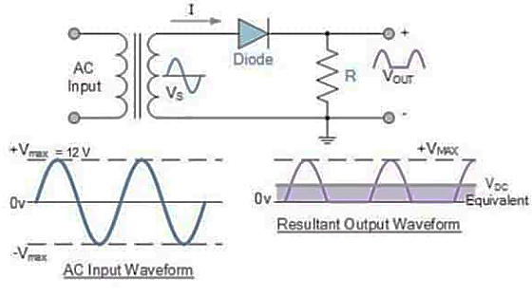
Fig. 2.1 The Half Wave Rectifier Circuit

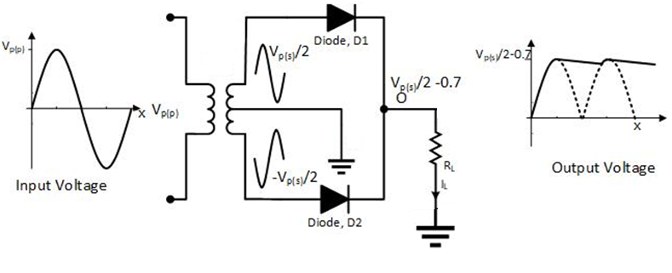
Fig. 2.2 The Center-Tapped Full Wave Rectifier Circuit with Capacitor Filter

Implementation: (Remove this content and replace it with photos with the following captions: )
Fig. 2.3 Component-side of the PCB
Fig. 2.4 Solder-side of the PCB
Fig. 2.5 Plot of the output waveform (on a graph page)

Ripple Factor Calculations:

Results:
Measured value of R = ______________
Ripple Factor, breadboard HWR circuit = __________
Ripple Factor, copper-clad HWR board circuit = __________
Ripple Factor, breadboard HWR circuit = __________
Ripple Factor, copper-clad HWR board circuit = __________

Challenges: (write the challenges you faced and overcame, more the challenges you overcome, more the marks, use Grammerly, not ChatGPT)

Conclusion:
Etching was practiced and performed using a Half Wave Rectifier Circuit and Full Wave Rectifier Circuit on a copper-clad board and its working was verified.

